ecoforge: an R package to simulate spatial explicit virtual species, environmental predictors, and sampling designs.
Authors: David Ferrer-Ferrando¹, Pelayo Acevedo¹, Pedro Tarroso²
¹ Instituto de Investigación en Recursos Cinegéticos (IREC), CSIC-UCLM-JCCM, Ciudad Real, Spain
² CIBIO, Centro de Investigação em Biodiversidade e Recursos Genéticos, InBIO Laboratório Associado, Campus de Vairão, Universidade do Porto, Vairão, Portugal
Corresponding author: David Ferrer-Ferrando, david.ferrer@uclm.es,

Abstract
Simulating ecological data under fully controlled and known conditions (the 'virtual ecologist' approach) is an effective way to test and compare sampling protocols and modelling tools, but the R packages that address this need each cover only part of the simulation pipeline, so users currently have to combine several of them and write substantial custom code. We present Ecoforge, an R package that integrates the entire pipeline within a single, modular framework: generating spatially autocorrelated environmental layers, deriving the expected abundance or suitability of a virtual species from them, simulating the spatial distribution of individuals through an inhomogeneous Poisson point process, and sampling these individuals under different field-realistic designs (point counts, transects, random or systematic grids) to obtain abundance or presence–absence datasets that account for imperfect detection. Ecoforge allows full control over every simulation step, making it possible to isolate the effect of specific design choices ( such as species spatial pattern or sampling strategy) on the performance of ecological models. We illustrate the complete workflow with a reproducible worked example, position Ecoforge relative to related R packages, and discuss its applications and current limitations. All the information required for installing and running Ecoforge is openly available on the GitHub repository https://github.com/NatureProtectionDFF/Ecoforge-R-package and website Ecoforge R package.
Keywords: virtual ecologist approach; spatial simulation; species distribution models; sampling design; imperfect detection; R package

1. Introduction
Understanding how a species' presence, abundance and spatial pattern relate to the environmental factors that shape them is a central goal in ecology, biogeography and conservation. These spatial patterns emerge from the interplay between abiotic conditions, such as climate, topography or soil properties, and biotic factors, including resource availability and interactions with other co-occurring species (Wisz et al. 2013). Characterizing this species-environment relationship, and projecting it in space, underlies spatial pattern models, such as species distribution models (SDMs) or habitat selection ones, which are now used routinely across terrestrial, freshwater and marine systems (Elith and Leathwick 2009).
Traditionally, this relationship has been characterized empirically by ecologists: presence, presence–absence or abundance records for a wide range of taxa are collected in the field and related, through a chosen statistical or machine-learning algorithm, to a set of candidate predictor variables. This approach has produced a vast body of knowledge, but it is also vulnerable to errors and alterations that are not always apparent to the analyst. Different modelling algorithms applied to exactly the same data can yield markedly different predictions (Elith et al. 2006), and the reliability of any of them is itself sensitive to characteristics of the data used, such as sample size, prevalence or the spatial pattern of the records (Hernandez et al. 2006), as well as to the sampling design and the detection process that generated those records in the first place (MacKenzie et al. 2002). Because the true species–environment relationship in the field is never fully known, these sources of error are difficult to identify, let alone quantify, from empirical data alone.
One way to address this is to take the opposite route: rather than starting from real data of unknown reliability, ecologists generate fully artificial simulated data for which every relevant property (e.g. the spatial pattern of the environment, the species' true relationship with it, the sampling design, or the detection process) is set by the researcher and therefore known with certainty. This 'virtual ecologist' approach (Zurell et al. 2010) makes it possible to apply a given algorithm or sampling design to data of known and controlled origin. By allowing for a direct comparison of the results against this known truth, isolating the contribution of each source of error identified above. While with real-world data, this ability to identify sources of error is diminished (Meynard and Kaplan 2011).
Implementing a simulation with the full ‘environment-to-dataset’ pipeline (generating a spatially structured environment layers, defining a virtual species suitability, placing individuals in space, collecting data under a given sampling design, and preparing those data for modelling) requires considerable methodological machinery. A wide diversity of R packages address part of this workflow (Table 1). Some generate spatially autocorrelated environmental layers (e.g. gstat, Pebesma 2004; NLMR combined with landscapetools, Sciaini et al. 2018), but provide no means of turning these surfaces into a species' distribution; others build a realistic species' suitability or occurrence pattern from user-supplied environmental data, but does not generate the environmental layers themselves (e.g. virtualspecies, Leroy et al. 2016); others simulate spatial point patterns more generally, which could represent the spatial distribution of individuals, but without any ecological perspective (spatstat, Baddeley and Turner 2005), or simulate spatial-explicit species’ individual distributions, but starts from a user-specified species-abundance distribution and spatial-aggregation index rather than from explicit environmental drivers (e.g. mobsim, May et al. 2018); and other include some sample functions, but do not include huge variability of field-designs or the individual distributions are not based on environmental layers (e.g. virtualspecies, Leroy et al. 2016; mobsim, May et al. 2018). Therefore, no single package currently covers the whole process (Table 1), and researchers wanting to do so must combine several of these tools and write considerable custom code, which limits reproducibility and standardization across studies.
Table 1. Core functionality of 'ecoforge' relative to comparable R packages for ecological simulation, based on the descriptions in their respective publications. ✓ = implemented; (✓) = partially or minimally implemented; – = not implemented.
Functionality | NLMR/ landscapetools | gstat | virtualspecies | mobsim | spatstat | Ecoforge
Generate spatially autocorrelated environmental layers | ✓ | ✓ | – | – | – | ✓
Build suitability/abundance surface derived from environmental layers | – | – | ✓ | – | – | ✓
Simulate spatial point patterns representing individual’s distribution | – | – | (✓) | ✓ | ✓ | ✓
Functions with different field sampling designs | – | – | (✓) | ✓ | – | ✓
Transformation to presence/absence data with possible imperfect detection | – | – | ✓ | – | (✓) | ✓
Processing datasets ready for analysis | ✓ | – | ✓ | ✓ | – | ✓

The R package ecoforge was developed to fill this gap. It implements the entire simulation process for studies of organism-environment spatial interactions within a single package: the generation of spatial-explicit environmental predictor variables (with a user-defined degree of spatial autocorrelation based on gstat), the definition of a target species' spatial distribution as a function of these predictors, the simulation of individuals in space following the species’ distribution pattern (following an inhomogeneous poisson point process based on spatstat), the sample of those individuals under different field-realistic designs (transects or fixed points, uniform or random structure), and the processing of the resulting records into a clean format ready for statistical modelling (abundance, presence/absence or detection/not-detection data). Because every step of the pipeline is explicit and under the user's control, ecoforge allows researchers to isolate and quantify the effect of specific design or methodological choices (such as the sampling strategy used, or the type of data employed), or the effect of ecological aspects of the species (such as the spatial pattern of the species, or the tolerance degree), on the performance of downstream analyses. The package has already been used to generate the simulates datasets, underlying a published assessment of how spatial scale/resolution of predictors and species spatial pattern affect the relationship between estimated suitability and true abundance (Ferrer-Ferrando et al. 2025). In this note, we describe the design and core functionality of ecoforge and illustrate its use with a worked example covering the full pipeline, from the generation of environmental layers to the production of a clean sampled dataset.

2. The ecoforge package

2.1 Features of the package
ecoforge is written entirely in the R language (R Core Team) and requires R ≥ 4.0. Version 1.0, the version described in this note, is distributed through the GitHub repository NatureProtectionDFF/Ecoforge-R-package, together with a documentation website built with pkgdown (https://natureprotectiondff.github.io/Ecoforge-R-package/) that includes the full function reference and the worked example used in Section 3. Installation instructions, kept up to date independently of this note, are given on that website; the current release can be installed directly from GitHub with devtools::install_github("https://github.com/NatureProtectionDFF/Ecoforge-R-package "). The package is released under the GPL-3.0 licence. ecoforge depends on six other R packages: stats (R Core Team), gstat (Pebesma 2004), terra (Hijmans 2025), spatstat.geom and spatstat.random (Baddeley and Turner 2005), and knitr (Xie 2015), the last of which is used to build the package vignette rather than by any exported function. The package builds on two existing computational engines rather than reimplementing spatial simulation methods itself: gstat provides the unconditional Gaussian random field simulation, with a spherical covariance model, that underlies every environmental-layer-generating function (generateVar(), generateClim() and their monthly-downscaling counterparts); spatstat.geom and spatstat.random provide the inhomogeneous Poisson point-process machinery used by generatePoints() to place individuals in space. terra is used throughout the package for raster handling, coordinate reference systems and the conversion between raster and tabular (data frame) formats used by the sampling functions. Building on these widely used and actively maintained packages, rather than reimplementing their functionality, both reduces the maintenance burden on ecoforge and ensures that its outputs (SpatRaster objects, spatstat 'ppp' objects) remain directly interoperable with the broader R spatial-ecology ecosystem, including species distribution modelling packages that could be combined with ecoforge as mentioned in Section 4, such as dismo (Hijmans et al.)], used in the worked example to derive bioclimatic variables (Section 3.2).
Function names in ecoforge follow a consistent, action-based naming convention tied to the simulation stage they belong to (generate*() for layer- and pattern-generating functions, *Samp()/*Sample() for sampling-design functions; Table 2), rather than a package-specific prefix; name clashes with other loaded packages have not been identified to date; if any should be identified, they can be resolved with namespaced calls (ecoforge::function_name()). Every exported function is documented with a help file detailing its arguments, return value and a runnable example, accessible via the standard R help system (?function_name) and rendered on the package website. The full worked example described in Section 3 is distributed as a package vignette and is runnable end-to-end without any external data. The package is under active development; users are encouraged to consult the GitHub repository for the latest release and to report issues or suggest improvements via the repository's issue tracker.

2.2 Package design
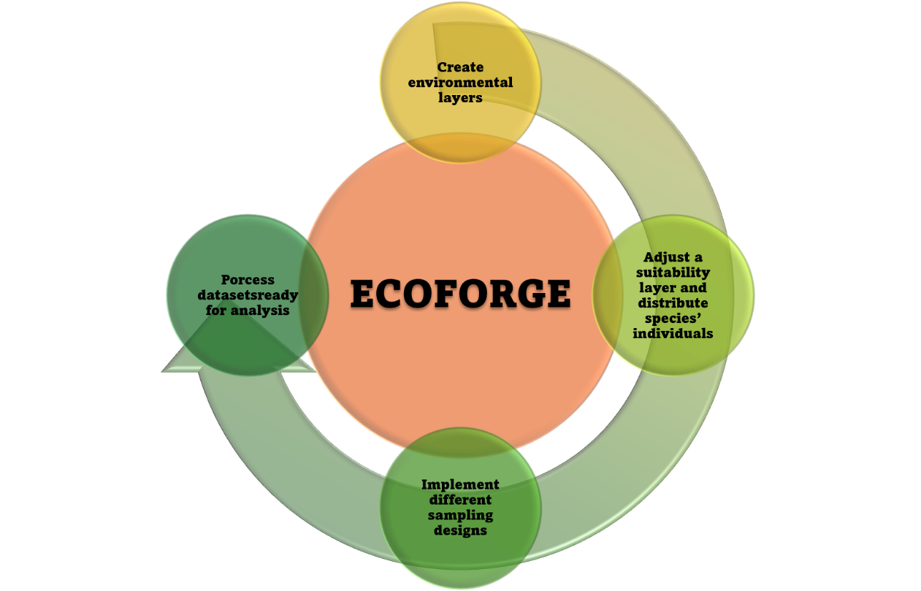
ecoforge is organised around four thematic groups of functions that mirror the successive stages of a virtual ecology simulation: (A) generation of environmental spatial layers, (B) adjustment of a species’ suitability/expected abundance layer and distribution of its individuals within this layer, (C) implementation of different field-based sampling designs to collect data, and (D) conversion of the sampled data into formats ready for statistical analysis (Fig. 1, Fig. 2). Although the functions are typically chained in this order, each one returns a standard R object (a data frame, a SpatRaster, or a spatstat 'ppp' object) and can equally be combined with other packages (see Section 4) or used independently of the rest of the pipeline.
Fig. 1. General workflow addressed by ecoforge: generation of environmental spatial layers, adjustment of a suitability/expected abundance layer and distribution of species’ individuals within this layer, collection of sampled data, and conversion of the sampled data into formats ready for statistical analysis.

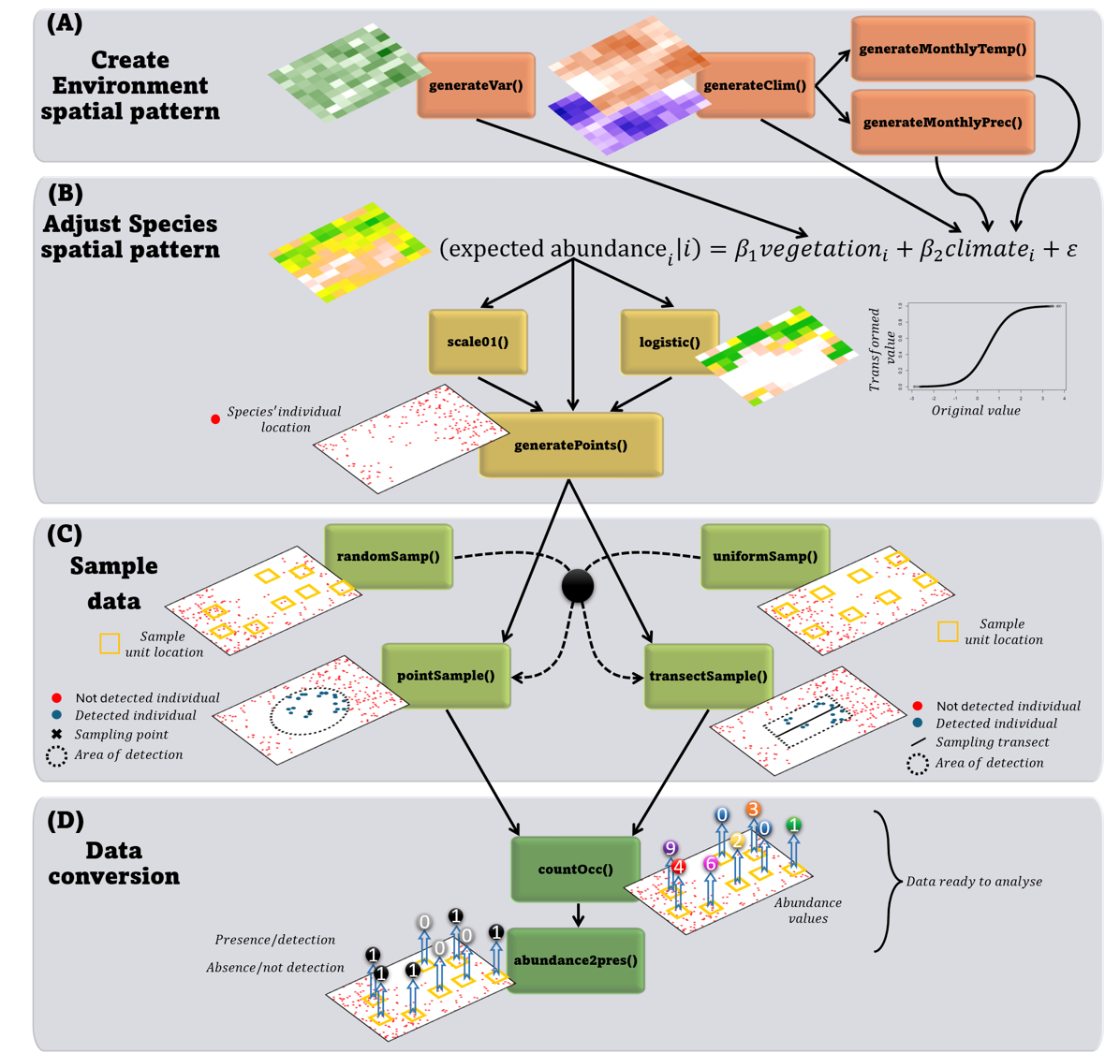
Fig. 2. Flowchart of the functions exported by ecoforge and their relationships, organised by simulation stage (A–D).

2.2.1 Generating environmental spatial patterns
generateVar() creates a single spatially autocorrelated variable on a regular grid, with the user controlling the grid dimensions and the mean, standard deviation and spatial-autocorrelation range of the variable; it is intended to represent any environmental gradient or patchy resource, e.g. vegetation cover or a terrain attribute. generateClim() extends this logic to generate a coupled, internally consistent set of climatic layers (temperature and precipitation), each with its own degree of spatial autocorrelation, while generateMonthlyTemp() and generateMonthlyPrec() downscale these annual layers into monthly minimum, mean and maximum temperature, and into precipitation following a user-defined seasonal pattern, respectively.

2.2.2 Data transformation
Two utility functions translate raw environmental layers into the currency used by the rest of the pipeline. scale01() linearly rescales any variable to the [0, 1] range, while logistic() applies a three-parameter logistic transformation — defined by an inflection point, an asymptote and a steepness parameter — that can turn a linear environmental gradient into a sigmoidal response curve. Used on their own, or in combination, these two functions let the user flexibly translate an environmental layer (or a combination of layers) into a habitat-suitability or expected-abundance surface, with the niche breadth and the linearity of the species–environment relationship entirely under their control.

2.2.3 Generating the species' spatial pattern
generatePoints() takes a suitability or expected-abundance raster and an approximate target number of individuals, and returns a spatstat 'ppp' point-pattern object representing the realised position of every individual of the virtual species across the study area. Because this point pattern is generated stochastically, as a realisation of an inhomogeneous Poisson process, the precise number and configuration of points varies between simulation runs, while their average density follows the input raster. This object constitutes the fully known, 'true' spatial pattern of the virtual species against which any later, sample-based estimate can subsequently be compared.

2.2.4 Sampling design and data extraction
The remaining functions implement the observation process: where surveys take place, what they detect, and how the resulting data are summarised. Sampling locations can be placed either on a regular, systematic grid with uniformSamp(), or at random positions within a user-defined extent and minimum spacing with randomSamp(). Given a set of survey locations and the 'true' point pattern of individuals, pointSample() and transectSample() simulate two common field-sampling designs. pointSample() computes, for every individual, its distance to each survey point and retains only those within a user-specified detection radius (a point-count design), while transectSample() centres a linear transect of a given length at each survey location — with either a random or a user-defined orientation — and retains the perpendicular distance of every individual within a chosen detection range on either side of the line (a line-transect design). Finally, countOcc() summarises these distance matrices into a simple count of detected individuals per sampling unit, producing an abundance dataset, and abundance2pres() converts these counts into presence–absence data while additionally accounting for an imperfect, per-individual detection probability, modelled as a binomial draw: a sampling unit is recorded as a presence if at least one of the individuals within range is actually detected. Together, these functions let users separate, and independently manipulate, the geometric component of detectability (distance to the observer) from an additional, purely probabilistic imperfect-detection component, in the spirit of the observer models discussed by Zurell et al. (2010).
Table 2. Functions currently exported by 'ecoforge', grouped by simulation stage.
Stage | Function | Description
A. Environmental pattern | generateVar() | Generates a single spatial-explicit variable layer with a user-defined degree of spatial autocorrelation
 | generateClim() | Generates a coupled set of spatial-explicit climatic layers (temperature, precipitation) with a user-defined degree of spatial autocorrelation
 | generateMonthlyTemp() | Downscales annual temperature into monthly min/mean/max values
 | generateMonthlyPrec() | Downscales annual precipitation into a seasonal monthly pattern
B. Data transformation | scale01() | Linearly rescales a variable to [0, 1]
 | logistic() | Applies a logistic transformation to a variable
C. Species spatial pattern | generatePoints() | Places individuals in space following an inhomogeneous Poisson point process
D. Sampling design | uniformSamp() | Places survey sites on a regular grid
 | randomSamp() | Places survey sites at random positions
 | pointSample() | Simulates point-count surveys within a detection radius
 | transectSample() | Simulates line-transect surveys within a detection range
E. Data extraction | countOcc() | Counts detected individuals per survey site
 | abundance2pres() | Converts counts to presence–absence under imperfect detection

3. Workflow and case study

3.1 Overview
To illustrate how the functions described above operate together, we provide a fully reproducible case study, distributed with the package as the 'Package Example' vignette. The example builds a complete virtual-species scenario and is structured around five stages: (i) generation of environmental spatial layers, including a coupled climatic dataset (temperature and precipitation, together with their derived monthly values and standard bioclimatic variables) and an additional non-climatic predictor (vegetation); (ii) construction of a habitat-suitability (or expected-abundance) surface for a target species by standardising and combining these predictors; (iii) generation of the species' 'true' spatial pattern, with the option of introducing a controlled distribution or detection bias; (iv) definition of a sampling design and simulation of the survey process, including imperfect detection; and (v) export of every simulated product, together with a worked example of how to use the resulting environmental layers to screen candidate predictors for collinearity before model fitting.

3.2 Generating environmental layers
A coupled set of climatic layers is generated with generateClim(), which lets the user set the mean, variability and spatial-autocorrelation range of both temperature and precipitation, together with their daily and annual amplitude; in the example these amplitude and range parameters follow a latitudinal gradient, so that cells at higher (simulated) latitudes show greater intra-annual variability. generateMonthlyTemp() and generateMonthlyPrec() then downscale these annual layers into twelve monthly values (minimum, mean and maximum temperature; cumulative precipitation), reproducing, in this case, a Mediterranean-like seasonal pattern in which the warmest months are also the driest. These monthly series can be passed directly to the biovars() function of the dismo package (Hijmans et al.) to derive the 19 standard bioclimatic variables widely used in species distribution modelling, e.g. as implemented in the WorldClim database (Hijmans et al. 2005), making 'ecoforge'-simulated climates directly compatible with typical downstream SDM workflows. An independent, non-climatic predictor (vegetation cover) is added with generateVar(). Critically, every layer can subsequently be resampled to coarser spatial resolutions with terra::aggregate(), allowing the same simulated landscape to be analysed at multiple spatial grains — an application central to a recent assessment of how spatial scale interacts with species spatial pattern (Ferrer-Ferrando et al. 2025).

3.3 Building a hábitat-suitability surface
Predictors are first standardised (scale()) so that each contributes on a comparable footing, and a small Gaussian error layer is added to represent unexplained variation. These are then combined, with user-defined weights, into a single linear predictor analogous to a Generalised Linear Model (e.g. LAM = 0.5·temperature + 0.5·precipitation + 0.5·vegetation + error in the worked example). Because this linear predictor is unbounded and approximately Gaussian, logistic() is used to reshape it into a bounded suitability index between 0 and a user-defined maximum. The inflection point (x0) of this transformation determines whether the resulting virtual species behaves as a narrow-niche specialist or a broad-niche generalist, while the steepness parameter (k) controls its tolerance to departures from the optimum — a flexible, closed-form analogue to the response-curve approach used in other virtual-species frameworks (e.g. Leroy et al. 2016). Values are finally rounded so that unsuitable areas take an exact value of zero.

3.4 Generating, and optionally biasing, the species' distribution
generatePoints() turns the resulting suitability surface into the species' 'true' spatial pattern as a realisation of an inhomogeneous Poisson process (40 000 individuals in the worked example). The vignette further demonstrates how this 'true' pattern can be made to reflect imperfections common in real datasets, by retaining only a user-defined fraction of individuals with a probability proportional either to a single spatial coordinate (a simple directional bias) or to proximity to a set of simulated population centres, mimicking the accessibility-driven bias often present in opportunistic or citizen-science records. Because the fully unbiased pattern remains available throughout, users can directly quantify how such biases propagate into any downstream estimate.

3.5 Sampling design and detection
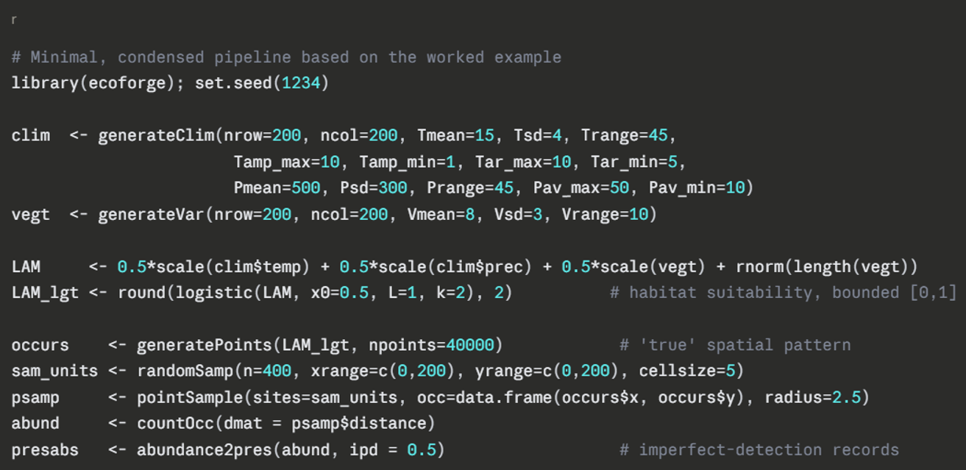
Survey locations can be drawn at random from a candidate grid with randomSamp(), or placed on a fully regular grid with uniformSamp() (e.g. to emulate a camera-trap layout). Given these locations and the 'true' point pattern, pointSample() (fixed-point design) and transectSample() (line-transect design, with random or user-defined orientation) each return, for every individual within range, its distance — perpendicular to the line, in the case of transects — to the nearest survey unit; this output is directly usable in distance-sampling or hierarchical detection models, or can be summarised into a simple per-site count with countOcc(). Finally, abundance2pres() converts these counts into detection/non-detection records, modelling an additional, imperfect per-individual detection probability.

3.6 Exporting data and checking covariate collinearity
Every simulated product — the sampled dataset, the suitability/abundance surface, the bioclimatic and vegetation layers (at every resolution generated), and the original climate layers — can be exported as standard raster (ASCII) and tabular (csv) files ready for use in external software; layers are kept strictly positive when exporting, to avoid the zero and negative values that can cause problems in some SDM software (e.g. Maxent). As a final, complementary step, the vignette illustrates good predictor-selection practice using the package's own outputs: a correlation matrix among the simulated bioclimatic variables is converted to a dissimilarity matrix and clustered (stats::hclust()), allowing variables more correlated than a chosen threshold (|r| > 0.8 in the example) to be identified and reduced to one representative per cluster before model fitting.

4. Discussion

4.1 Contribution and scope
As shown in Section 2.1, 'ecoforge' is, to our knowledge, the first R package to integrate the full virtual-ecologist pipeline (Zurell et al. 2010) — environment, species pattern and field sampling — within a single, modular framework, occupying a middle ground between simple pattern-generating tools (e.g. NLMR/landscapetools, virtualspecies) and fully process-based, individual-based platforms such as RangeShiftR (Malchow et al. 2021). This explicit control over spatial structure is not incidental. Spatial autocorrelation in environmental and species data is known to affect the performance and inferential validity of the statistical models commonly used in ecology (Dormann et al. 2007), so a tool that lets users set, rather than merely inherit, the degree of autocorrelation of every layer, and that lets them resample the same simulated landscape at different spatial grains, provides a direct way of testing how robust a given model or sampling design is to this source of variation; this is precisely the application already demonstrated, using part of the package, in Ferrer-Ferrando et al. (2025). Because every function returns a standard R object and can be used independently of the rest of the pipeline, 'ecoforge' can also be combined with other spatial or modelling packages well beyond the specific workflow illustrated in Section 3, and its fully controlled scenarios make it a useful tool for teaching core concepts in spatial and population ecology.

4.2 Limitations and future directions
The current implementation has some limitations that point to natural directions for future development. First, 'ecoforge' generates a single, static spatial pattern for one species at a time; it does not yet model demographic processes, dispersal or interspecific interactions through time. Linking its environment- and suitability-generating functions to a process-based, individual-based platform such as RangeShiftR (Malchow et al. 2021), or extending its species-pattern functions toward the multi-species framework implemented in mobsim (May et al. 2018), would allow users to combine 'ecoforge''s fine control over spatial structure with explicit population or community dynamics. Second, detection is currently modelled either as a hard geometric cutoff (individuals within a fixed radius or range are detected, others are not) combined with a constant, per-individual imperfect-detection probability, rather than as a continuous, covariate-dependent detection function. Making 'ecoforge''s point-count and transect output directly compatible with established detection-function estimation tools such as the Distance package (Miller et al. 2019) would let users simulate data under more realistic detection processes and immediately re-analyse them within the same, well-established statistical framework. Third, the package currently represents study areas as two-dimensional rasters and does not support network-based or fully continuous spatial representations. Finally, 'ecoforge' is currently distributed only through GitHub; ongoing work includes the addition of a unit-test suite and continuous-integration checks, and a future submission to CRAN, to widen its accessibility and support its long-term maintenance. The package is open source (GPL-3.0) and we welcome contributions addressing any of these points.
Process-based, individual-based platforms such as RangeShiftR (Malchow et al. 2021) explicitly simulate the demographic and dispersal mechanisms, through multiple time steps, that generate a species' range; this provides a more mechanistic, but considerably more heavily parameterised, alternative to the single-time-step, pattern-based approach taken by 'ecoforge'. 'ecoforge' is best seen as supplementing, rather than competing with, all of these tools: its environment- and species-pattern-generating functions could, for instance, supply the spatial input layers used by RangeShiftR, while its sampling and detection functions could equally be applied to occurrence patterns generated by virtualspecies or mobsim.

5. Software availability — [pendiente: cerrar cuando estén DOI/versión/tests]

Acknowledgements / Funding / Author contributions — [pendiente]

References (se irán añadiendo conforme avancemos)
Baddeley, A. and Turner, R. 2005. spatstat: an R package for analyzing spatial point patterns. – J. Stat. Softw. 12: 1–42.
Dormann, C. F., McPherson, J. M., Araújo, M. B., Bivand, R., Bolliger, J., Carl, G., Davies, R. G., Hirzel, A., Jetz, W., Kissling, W. D., Kühn, I., Ohlemüller, R., Peres-Neto, P. R., Reineking, B., Schröder, B., Schurr, F. M. and Wilson, R. 2007. Methods to account for spatial autocorrelation in the analysis of species distributional data: a review. – Ecography 30: 609–628.
Ferrer-Ferrando, D., Tarroso, P., Tellería, J. L., Acevedo, P. and Fernández-López, J. 2025. Disentangling the effect of the spatial scale and species spatial pattern on the abundance–suitability relationship. – Ecography 2025: e07766.
Hijmans, R. J., Cameron, S. E., Parra, J. L., Jones, P. G. and Jarvis, A. 2005. Very high resolution interpolated climate surfaces for global land areas. – Int. J. Climatol. 25: 1965–1978.
Leroy, B., Meynard, C. N., Bellard, C. and Courchamp, F. 2016. virtualspecies, an R package to generate virtual species distributions. – Ecography 39: 599–607.
Malchow, A.-K., Bocedi, G., Palmer, S. C. F., Travis, J. M. J. and Zurell, D. 2021. RangeShiftR: an R package for individual-based simulation of spatial eco-evolutionary dynamics and species' responses to environmental changes. – Ecography 44: 1443–1452.
May, F., Gerstner, K., McGlinn, D. J., Xiao, X. and Chase, J. M. 2018. mobsim: an R package for the simulation and measurement of biodiversity across spatial scales. – Methods Ecol. Evol. 9: 1401–1408.
Meynard, C. N. and Kaplan, D. M. 2011. The effect of a gradual response to the environment on species distribution model performance. – Ecography 35: 499–509.
Miller, D. L., Rexstad, E., Thomas, L., Marshall, L. and Laake, J. L. 2019. Distance sampling in R. – J. Stat. Softw. 89: 1–28.
Pebesma, E. J. 2004. Multivariable geostatistics in S: the gstat package. – Comput. Geosci. 30: 683–691.
Sciaini, M., Fritsch, M., Scherer, C. and Simpkins, C. E. 2018. NLMR and landscapetools: an integrated environment for simulating and modifying neutral landscape models in R. – Methods Ecol. Evol. 9: 2240–2248.
Zurell, D., Berger, U., Cabral, J. S., Jeltsch, F., Meynard, C. N., Münkemüller, T., Nehrbass, N., Pagel, J., Reineking, B., Schröder, B. and Grimm, V. 2010. The virtual ecologist approach: simulating data and observers. – Oikos 119: 622–635.

